**Fertilizers Recommendation System For Disease Prediction – Problem Statement**

**Fertilizer Recommendation**: The user has to enter the Nitrogen, Phosphorus, Potassium values along with the crop Name. A POST request is made to the flask API. Over here the fertilizer recommendation classifier is hosted. An HTTP response is sent to the front-end and in turn on the front-end the user gets recommendation to fertilizer.

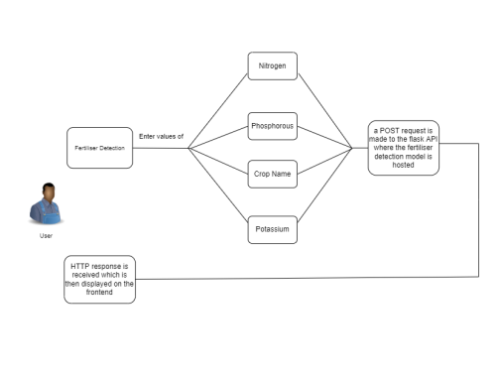

**Disease Detection:** In disease detection the user has to click an image or directly upload it. The image is sent to the back-end and is processed by the model. After the image has been processed an HTTP response is sent to the front-end. The user receives the disease the plant has and its remedies.

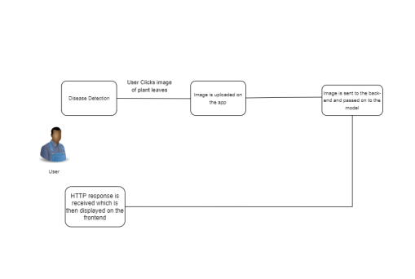

**Crop Recommendation:** On entering the values of Nitrogen, phosphorus, and Potassium a post request is made to the flask API. After the model runs an HTTP response is sent to the front-end which tells the best crop a farmer can grow in the soil in order to get the best out of the land.

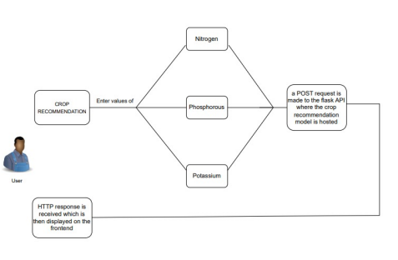

**News Feed:** The NDTV website has been scraped and then deployed as an API, when the user navigates to the news section of our website an HTTP response is sent to the frontend which displays latest news related to agriculture along with the link directed to the main article.

**Disease Portal:** The disease portal provides a detailed view of various plant diseases and the kinds of products that may be bought to cure the plants of the disease.

**Interpretability Analysis:** The plant leaf image uploaded by the user is sent to a deployed API where the LIME computation takes place, the computing is done on a droplet server hosted on Digital Ocean which sends the resultant image in form of URI which is then displayed on the front-end.

**Crop Protection & Management:** Develop smart & affordable solution to protect crops from wild animals(Technology Bucket: IoT, UAV, AI, GPS etc.) With the help of remote sensing technologies develop crop protection solution from wild animal attacks. Provide alerts on any crop damage in case animals destroy crops. In Vidarbha region, Main Cash Crops such as Pigeon Pea, Green Gram, Black Gram, Jowar, Cotton, Soybean etc. present and are badly affected by wild animals like Deer, Rohi (Neel Gai), wild Pigs, Peacock etc. In few districts in Vidarbha crop loss is more than 35%. Main Wild animals attacking crops in region are Akola, Buldhana Washim etc.

**Forecasting using Predictive Analytics:** Develop system for predicting potential pest, disease, insect attacks (before at least 15-day & more) on Cotton crop and yield prediction of cotton. (Technology Bucket: Big Data, Cloud computing, Satellite imagery, IoT data (on field sensors), Drone Imagery etc.). To develop app-based forecasting system which provide prediction of possible pest/disease/insect attack on Cotton crop &Predict the cotton crop yield production for Vidarbha region farmers based on the farm historical data, local terrain, weather scenario, various sensor inputs rather than generic guidance.